Admin:

Find user: In order to find a user enter the Username or First Name and Last Name

Add or update a user:

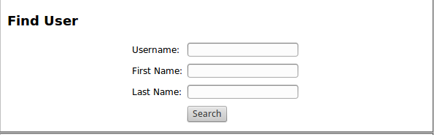
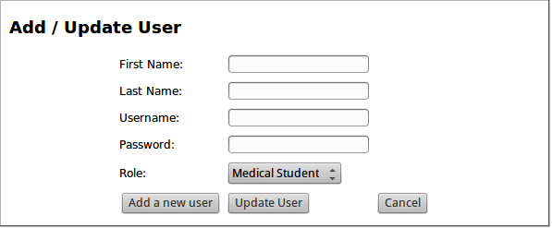
In order to update a user type in their First Name, Last Name, Username and New Password and click Update User

To add a user type in their First Name, Last Name, Username, New Password. Then select what role they will be fulfilling by via the dropdown menu and click Add User.

Researcher:
Once you have logged in you are presented with the following screen

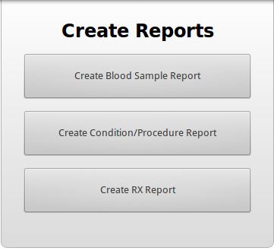
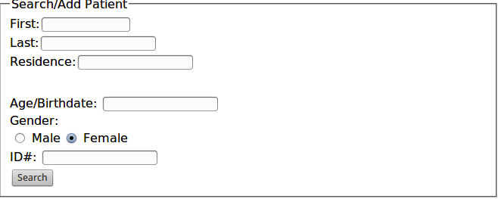
Once you have chosen what report you would like to create, simply choose where you wish to save it and hit submit.

Phamicist:

Once you have logged in type in the necessary information below and hit search.

Once you have selected the proper patient select what medicine was prescribed and what dosage then click submit.
Student:

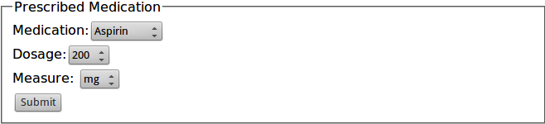

Once you have logged in either search for an existing patient by First Name and Last Name and click Search.

If the patient is new then enter their vitals and click Submit. If they are existing then once you have entered their vitals click the Start New Encounter button located at the bottom of the screen.

